*Homeschool Outdoor School!
Our 31st Year (rescheduled) – Sept 7-11, 2020
{Overnight Monday – Friday}
Oregon 4H Center – Salem, Oregon (For ages 9-16)
Kids Need Camp!!!
Outdoor learning sessions vary from year to year. But past classes have included fire building, outdoor cooking, compass course, survival and first aid. Also, we have activities such as fishing, archery, canoeing, volleyball. Accommodations: We stay in cabins and meals are prepared for us. (Please let us know your dietary needs.)
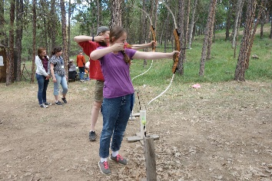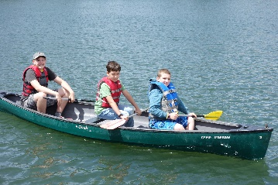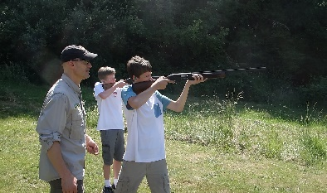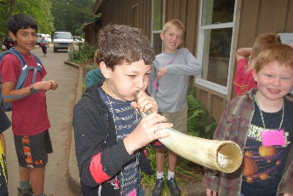

Day classes and recreation events vary each year and are partially dependent on parents who share their teaching or coaching gifts with the group. We couldn’t do this without the participation of a few parents who help us make this happen. We move camp from year to year to study different ecosystems and geologic areas of our great northwest. We strive to do different things each year because many kids come back. More details will follow about day classes offered this year.

Evening sessions are presented to build faith in the Bible’s teaching of the creation account and flood through compelling science presentations. This year our special speaker is Dr. Thomas Kindell. (YES HE WAS ABLE TO RESCHEDULE)

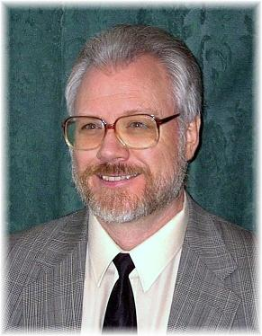
Dr. Thomas Kindell was once an ardent believer in the “fact” of evolution. However, through his exposure to the scientific case for creation, he became a zealous creationist. He has received advanced training in scientific creationism through the Graduate School of the Institute for Creation Research in Santee, California. He has been privileged to study under several of the world's most prominent creationist scientists. He also has studied Christian Apologetics and Biblical-Scientific Creationism at California Graduate School of Theology where he received his M.A. in Biblical Studies. He holds a Doctorate in Philosophy of Theology (major in philosophy of Biblical apologetics.)
Dr. Kindell is the founder and president of Reasons for Faith Ministries, Inc., a non-profit ministry dedicated to equipping Christian believers to “give every man an answer” for their Biblical faith. He is an ordained minister with the Calvary Chapel of Weston, TX. For over 35 years he has engaged in a traveling teaching ministry lecturing on Biblical apologetics and the scientific case for
creation.
He has also successfully debated the scientific case for creation against notable evolutionists on high school and college campuses, radio, and television. Dr. Kindell is a frequent guest on the radio series “Science, Scripture & Salvation” which is produced by the Institute for Creation Research. .
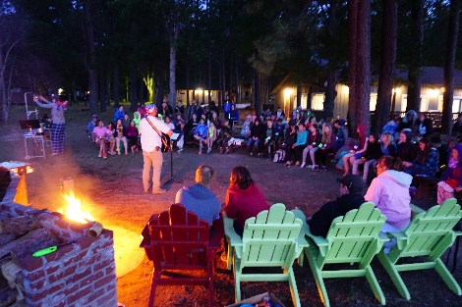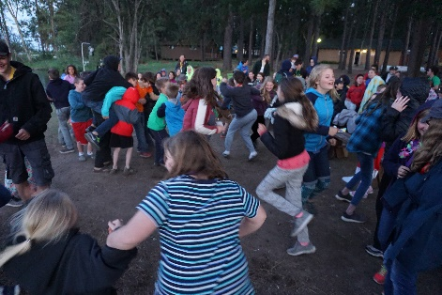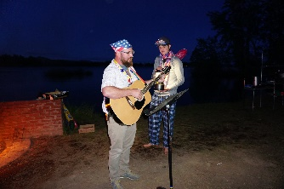
We cap off each day with homegrown entertainment around the campfire and a time of worship and devotions. Kids have fun spending the week with new friends, and so do adults.

Intellectual struggles are one of the reasons why kids leave the church. They hear evolution nonsense taught everywhere. Then they lose confidence in the Bible. This has been the goal of the ‘architects’ of evolution. If we don’t give them good answers, Satan wins this argument. Studies are showing that an understanding of creation and the Biblical flood of Noah’s day is key to retaining our kids in the faith. COME HEAR GREAT ANSWERS!!!

Make memories with your kids! PARENTS are strongly encouraged (but are not required) to attend as cabin counselors or teachers. We are always in need of Dads as counselors.

We know finances are tight for most, so we keep the costs as low as possible because we know you and your children will love this camp. It is so good for their social interaction with other homeschoolers that our family has made it a “must” to attend with our large family for the past 22 years with no regrets. Now our grand-children are coming. It’s that good!

$205 for Students, $30 early bird discount if registered with $50 refundable deposit by June 30th or $20 discount if registered by July 31st, $150 for Counselors. Deadline for registration Aug 23rd.

To apply go to: www.homeschooloutdoorschool.com and click on “Apply Now” and follow the instructions Please forward your questions to dbnett10@gmail.com
Like us on Facebook “HomeSchool Science Camp”

*Must have home-schooled the 2019/2020 school year to apply for this year’s camp.

